Design Doc Template

*Author(s): xyz*

*Date: 22/05/2019*

Revision: 0

Document Status: Draft [Draft, Completed, Submitted, Reviewed, Final]

Project Status: In-Progress [In Review, Approved, In-Progress, Completed]

Revision History

|  |  |  |  |
| --- | --- | --- | --- |
| Date | Revision | Description | Author |
| 22/05/2019 | 0 | Initial draft of the design doc template | xyz |
|  |  |  |  |
|  |  |  |  |
|  |  |  |  |
|  |  |  |  |
|  |  |  |  |
|  |  |  |  |
|  |  |  |  |
|  |  |  |  |
|  |  |  |  |

Table of Contents

TOC \o "1-3" \h \z \u Introduction4

Summary4

Background4

Definitions, Acronyms, and Abbreviations4

Design Overview4

Requirements4

Documentation4

Minimum Viable Product5

Stretch goals5

Future work5

Architectural Diagrams5

System Diagrams5

Application Programming Interface5

Recommendations5

User Interface6

Data Models and Storage6

Service Operability6

Key Performance Indicators6

Service Level Objectives6

Project Overview7

Communication and Tracking7

Risks7

Milestones7

Project Phases7

Cost7

Frequently Asked Question7

References7

Addendum8

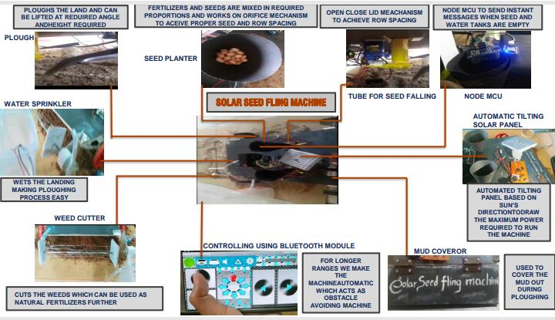

# Introduction

## Summary

37% of Indian rural population are farmers.Farmers, while sowing the seed, end up in spending most of their investment on labour and they also face spine problems. Our machine has capability of solving all they problems faced by farmers . While currently available solutions like seed sowing machines by various companies doesn't have all the features required, our machine is an integration of all of them.

## Background

Coming to seed planting, from ages many methods have been implemented but they resulted in low seed placement, less spacing efficiency and also caused severe spine problems to the farmers resulting in various health issues. Also the labour cost is increasing day by day and labour availability has become a great concern to the farmers. So we have developed a "SOLAR SEED FLING MACHINE" which includes simple yet effective features.

## Definitions, Acronyms, and Abbreviations

Fling - to sow

# Design Overview

## Requirements

As our product is economically feasible even small scale farmers can afford to buy our machine.

Any farmer using this machine need not have any special technical skills.

### Documentation:

Code comments :

Code used for ploughing mechanism- whenever the machine is switched on the servo motor attached to the plough digs into the land by rotating at an angle of 60 degrees and continues to be in that position.

Code for seed sowing mechanism - This code helps the servo motor to rotate slowly which reflects a gear mechanism.

References:

https://www.researchgate.net/publication/322629603_Design_and_Fabrication_of_Seed_Sowing_Machine

https://www.researchgate.net/publication/318988073_SOLAR_SEED_SOWING_MACHINE

ARCHITECTURL DIAGRAMS:



Application Programming interface

Arduino IDE fo programming the components required to control various operations of machine.

Project Overview

Communication and Tracking

Any relevant distribution lists, slack channels, taiga projects, etc

Risks

Anything that may put the project at risk; potential delays, dependence on work done by other teams, hardware procurement, or reviews.

Risks may also include assumptions of the project's external dependencies. These may be lower level project dependencies that are tracked outside of the immediate project scope and assumed to already be in place. For Me, "project x assumes OS version y will be available in the market."

Milestones

Estimated dates when planning steps, deliverables, and reviews will be completed

Project Phases

For projects that are better tracked and reported on in multiple phases because of extended timelines, external dependencies, etc

Cost

Level of effort, number of resources, number of hours or weeks, unlike milestones which tracks project time cost should only include engaged time.

1) For the all tasks which are deliverables/visible on user-end side needs to be documented as stories.

2) Need to guess/estimate the time required in number of hours for the completing that stories which can be captured in taiga.

3) Assign that task to the right person and document the actual time taken for completing that task.

Frequently Asked Question

References

Links to any supporting documentation, other projects, or reference material

Addendum

Additional diagrams or details that do not particularly belong in the body of the design doc. This could also be a place to describe additional examples that would otherwise bloat the introduction section. More specifics on APIs could also be placed here for engineers to reference.